***1)Install git.***

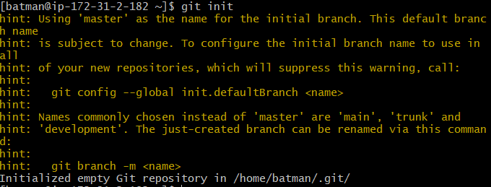

***2)Create a repo in github with README.md and .ignore file.***

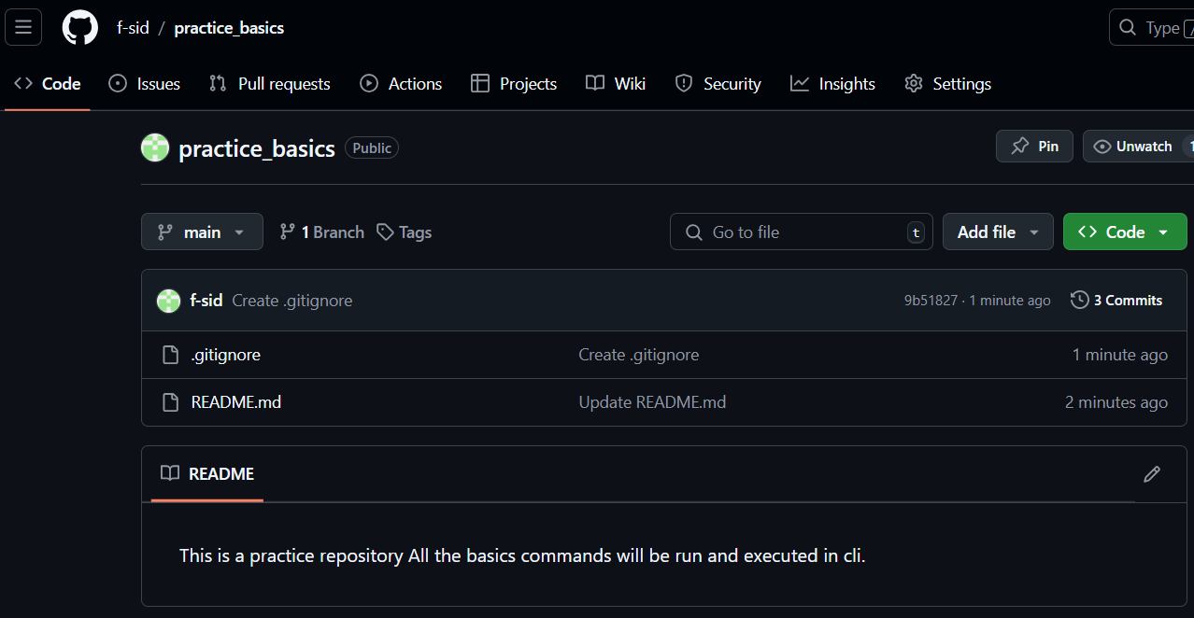

***3)Clone the created repo to local.***

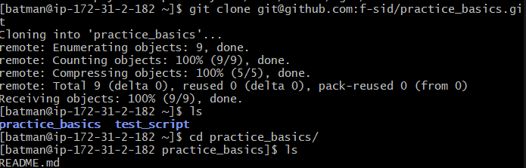

***4)Create two files in local repo.***

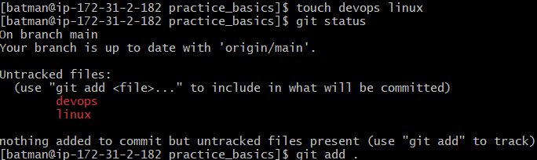

***5)Commit two files and push to central Repository.***

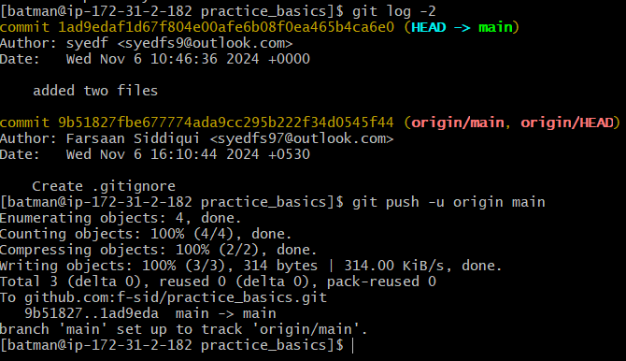

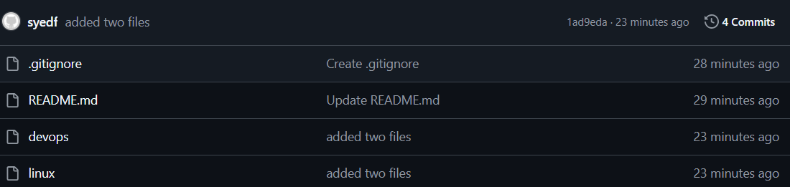

***6)Create a branch in local and create a sample file and push to central.***

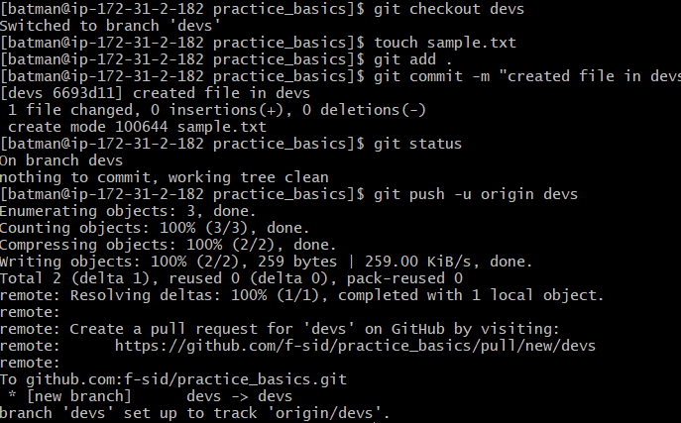

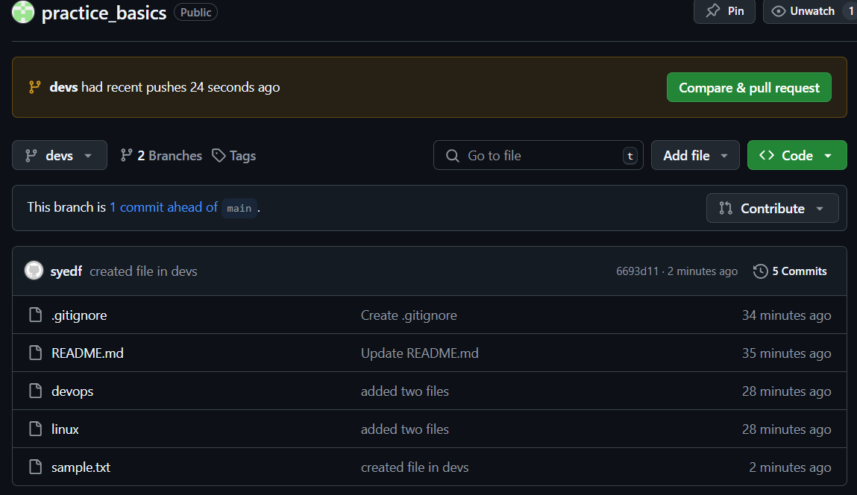

***7)Create a branch in github and clone that to local.***

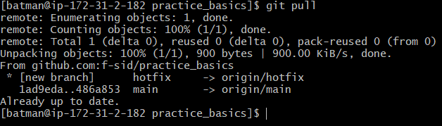

***8)Merge the created branch with master in git local.***

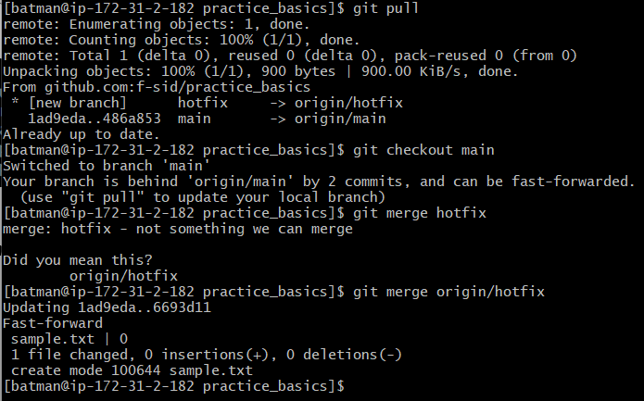

***9)Merge the created branch with master in github by sending a pull request.***

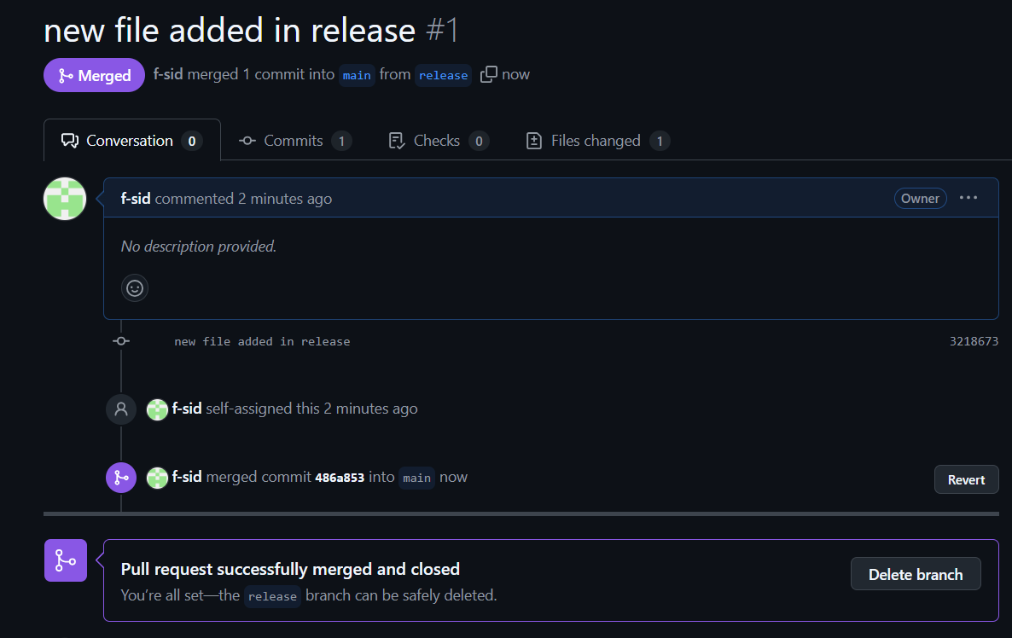 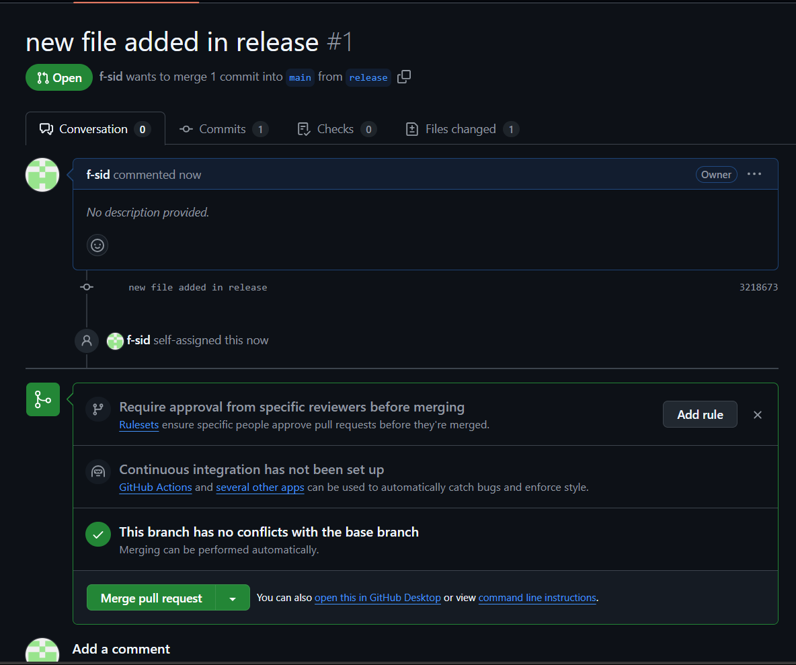

***10)create a file in local and send that to branch in github.***

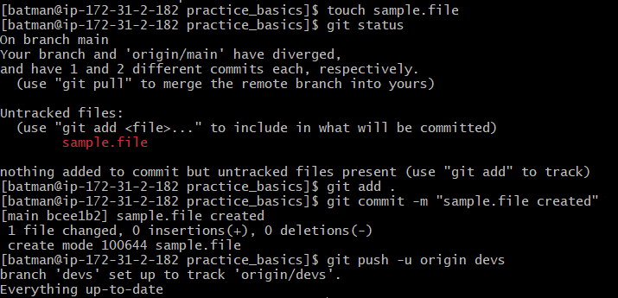

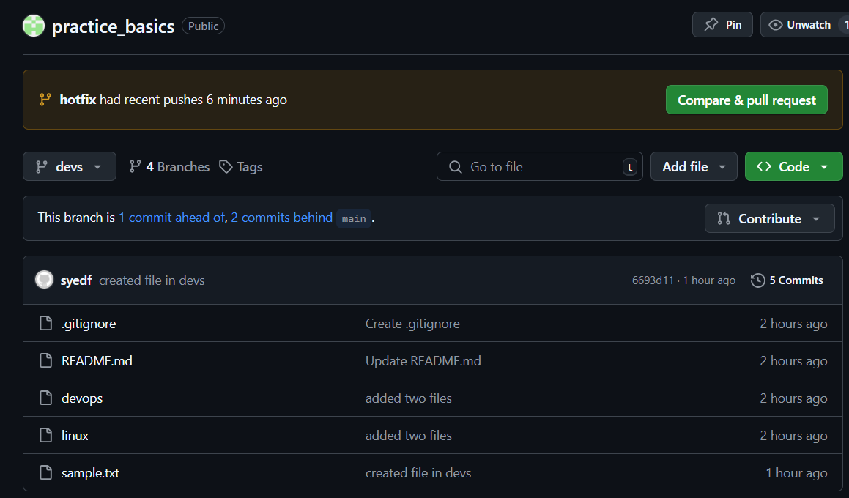

***11)clone only a branch from github to local.***

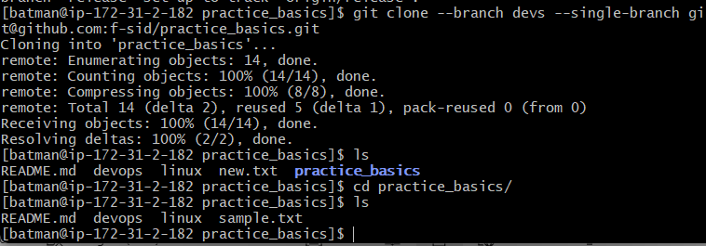

***12)create a file with all passwords and make that untrackable with git.***

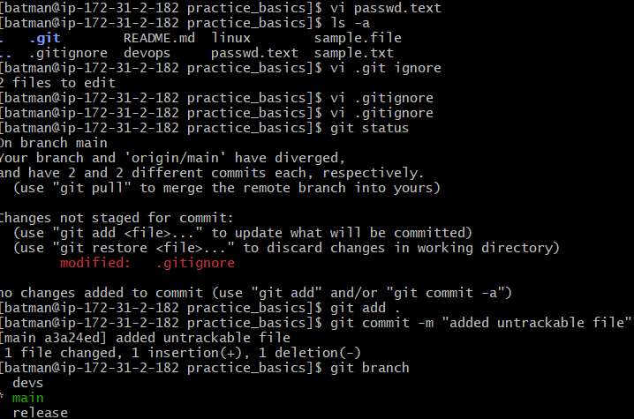

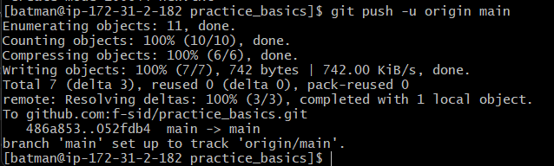

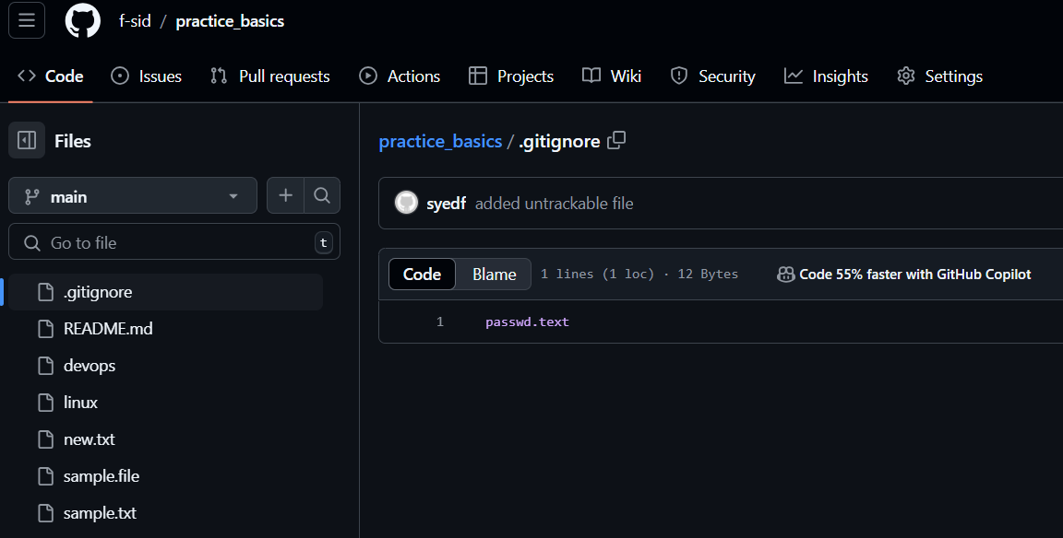

***13)make a commit and make that commit reset without savings changes.***

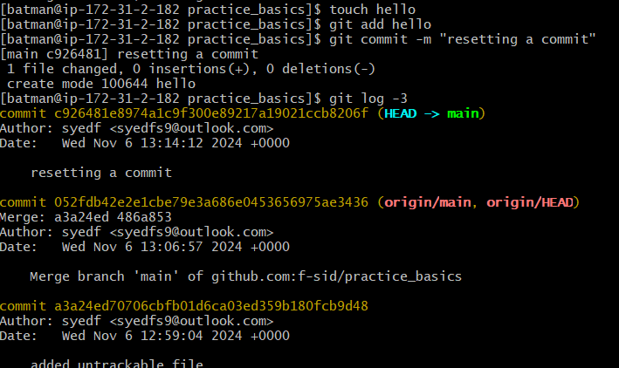 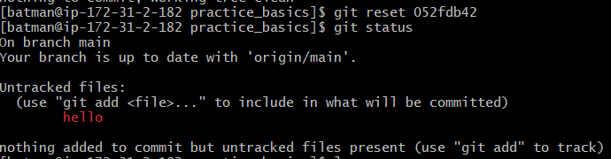

***14)Revert a commited commit to the older version.***

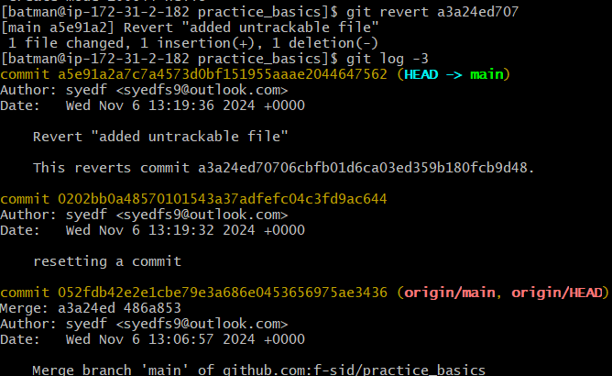

***15)push a file to stash without savings the changes and work on another file.***

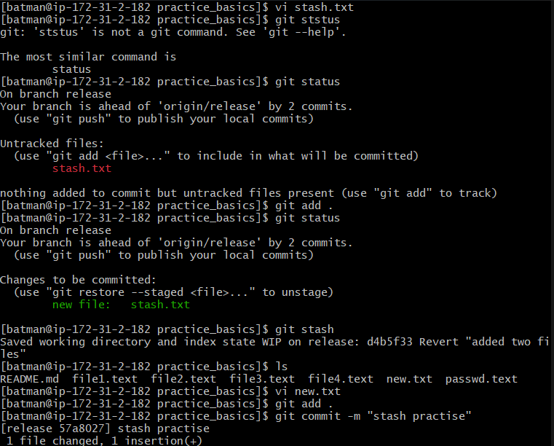

***16)undo the stash file and start working on that again.***

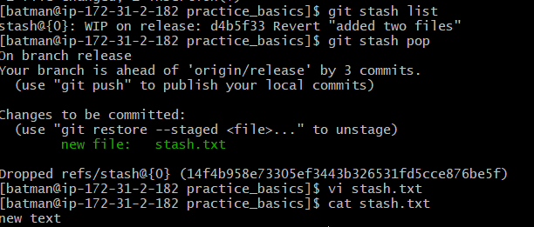

***17)generate a ssh-keygen and configure into github.***

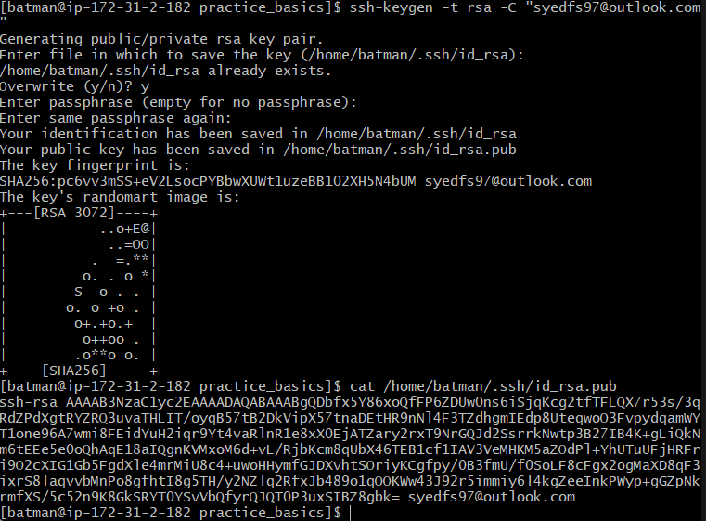

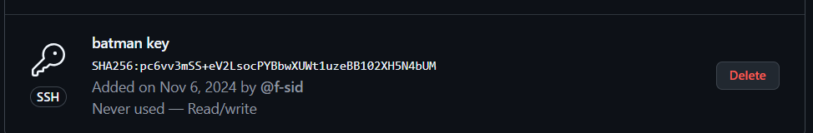

***19)basic understanding of .git file.***

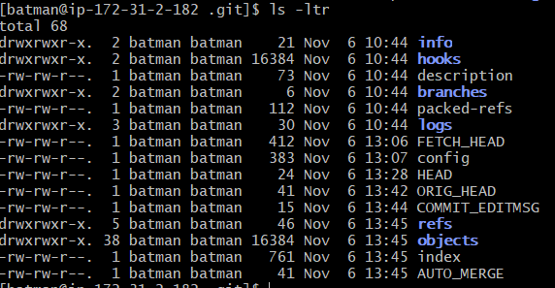

***20)Check all the logs of git.***

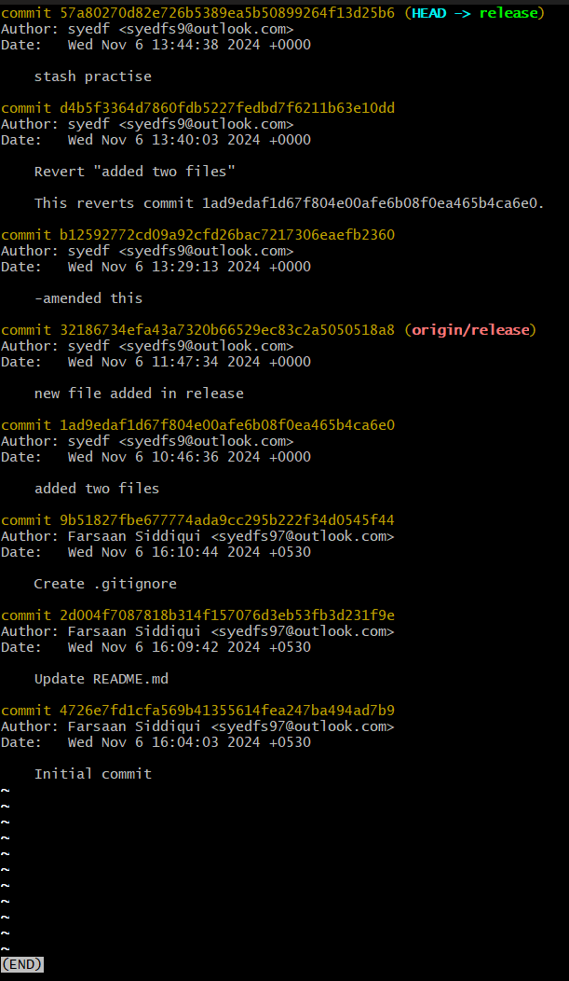

***21)Rename the commit message***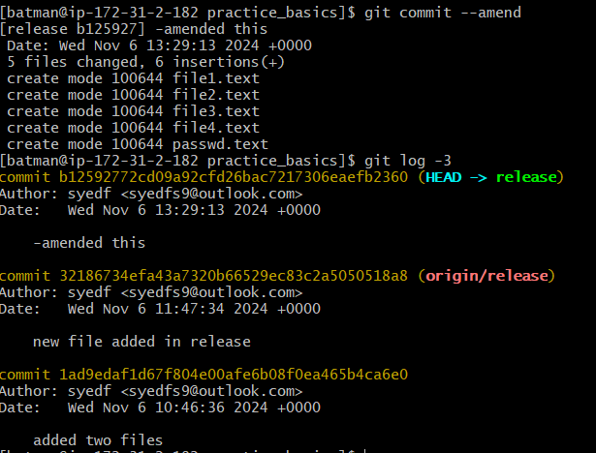

***22)Merge multiple commits into single commit.***

